03/10/25


PHONE - 877-312-7827 5/4/26
EMAIL - STARPAPERSTORE@GMAIL.COM

- CARBONLESS, LABELS
- OPAQUE DIGITAL, COATED DIGITAL
- ENVELOPES
- ENVELOPES BOOKLET AND CATALOG
- ENVELOPES (READY TO SEAL), (SECURITY TINT)
- LABELS, PRESSURE SENSITIVE STICKERS-value brand
- BOND 20# WHITE, 60# AND 70# TEXT WILLIAMSBURG
- TANGO DIGITAL C1S & C2S
- COATED GLOSS DIGITAL TITAN, ENDURANCE
- 24#, 28# 32# HAMMERMILL, POLARIS
- STARBRITE TEXT, COVER
- ACCENT TEXT, COVER ANNOUNCEMENT ENVELOPES
- GLOBE LINEN-value brand
- CLASSIC CREST, CLASSIC LINEN
- COLORS PASTEL 20#, 60# OFFSET
16. INDEX 90 & 110
- VELLUM BRISTOL 67#
- ASTROBRIGHTS
- BOXES, CHIPBOARD
- BINDERY, CLEAR COVERS, COMPOSTITION COVERS, COILS, LAMINATING POUCH
- SYNTHETIC PAPER, POLIPRINT POLYESTER, SYNAPS
- EASELS,
FOAMBOARD 24X36
- DOOR HANGERS JUMBO, FOLDER POCKET SETS
- ROLLS ENGINEERING BOND


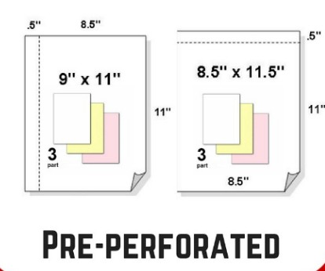
LABELS-STICKERS
PRICE PER 1,000 SHEETS
PERFORATED
WHITE, CANARY, PINK, GREEN, GOLD, BLUE also Tag Manilla & Tag White
CARBONLESS | 8.5 X 11 | 8.5 X 14 | 11 X 17 | 17.5 X 22.5 | 9x11 - 8.5x11.5  
2 PART COLLATED | 45.15 | 57.42 | 90.12 | CALL | 55.30
3 PART COLLATED | 50.85 | 64.72 | 101.60 | CALL | 62.20
4 PART COLLATED | 54.35 | 69.18 | 108.62 | CALL | 66.55
5 PART COLLATED | 58.92 | 75.05 | 117.85 | CALL | 72.34
6 PART COLLATED | 64.53
SINGLES | 8.5 X 11
CB | 56.94
CFB | 68.82
CF | 44.30
TAG CF | 130.73

LABEL STOCK PRESSURE SENSITIVE PERMANET FULL SHEET SIZE
(PRICE PER PACK OF 100 SHEETS)
 | 8.5 X 11 | 12 X 18 | 13 X19
UNCOATED | $32.62 | $51.37
MATTE | $34.28 | $56.83
GLOSS | $37.50 | $63.90 | $75.00
CLEAR | $69.90 | $
VINYL | $ | $125.33 | $138.00

877-312-7827

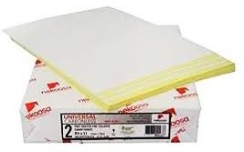




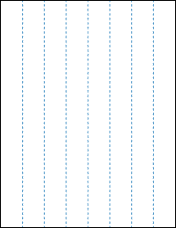
SLIT EVERY 1-1/4 INCH


05/4/26

VINYL REMOVABLE $130.00 $193.31

5/4/26

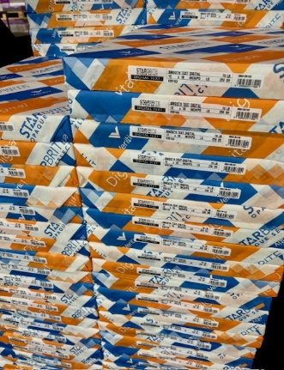
STARBRITE DIGITAL OPAQUE WHITE
 | 8.5X11 | 11X17 | 12X18 | 13X19
50 TEXT | 15.40 | 30.80 | 35.42 | 40.04
60 TEXT | 18.14 | 36.29 | 40.82 | 46.87
70 TEXT | 21.17 | 42.34 | 48.38 | 54.43
80 TEXT |  |  | 54.43 | 63.50
100 TEXT |  |  | 68.04
65 COVER |  | 72.38 | 83.16 | 95.48
80 COVER  100 COVER |  | 89.32 | 101.64  127.88 | 117.04  146.36

ENDURANCE GLOSS & SILK

 | 11X17 | 12X18 | 13X19
80 TEXT | 50.46  44.00 | 58.59  51.00 | 68.36  60.00
100 TEXT | 63.48  56.00 | 73.25  64.00 | 84.63  74.00
80 COVER | 96.03  85.00 | 109.27  97.00 | 125.82  111.00
100 COVER | 119.20  105.00 | 137.41  122.00 | 158.00  139.00
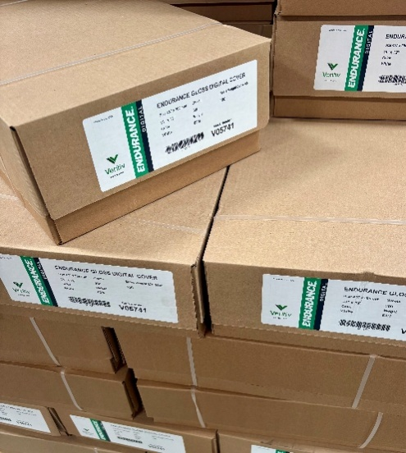

03/6/24

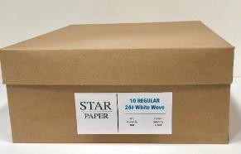
ENVELOPES
WHITE/WOVE -value brand

REGULAR
#6-1/4 REGULAR | $42.76 / 1000
#6-1/2 REGULAR | $43.11 / 1000
#6-3/4 REGULAR | $32.91 / 1000
#7 REGULAR | $41.04 / 1000
#7-3/4REGULAR | $41.83 / 1000
#8-5/8 CHECK REGULAR $41.83 / 1000
#9 REGULAR | $33.25 / 1000
#10 REGULAR | $34.30 / 1000
#11 REGULAR | $61.06 / 1000
#12 REGULAR | $73.07 / 1000
#14 REGULAR | $76.58 / 1000

WINDOW
#9 WINDOW | $43.12 / 1000
#10 WINDOW | $38.57 / 1000
DIGITAL #10 WINDOW | $48.80 / 1000
$10 RIGHT HAND | $45.62 / 1000
REMIT
#6-1/2 REMIT | $49.00 / 1000
#6-1/2 – 2 WAY REMIT | $119.41 / 1000
#9 REMIT | $57.75 / 1000

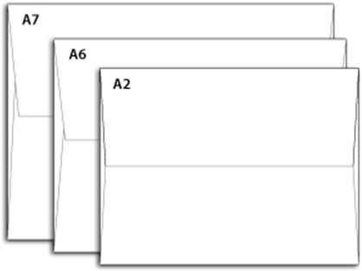
ANNOUNCEMENTS SEVILLE 24#
A-2 | $41.00 / 1000
A-6 | $47.00 / 1000
A-7 | $56.00 / 1000


02/18/26

READY TO SEAL 
#10 REGULAR $100.46 / 1000

#10 WINDOW $104.82 / 1000
DIGITAL #10 WINDOW $110.00 / 1000


SECURITY (BLUE TINT)
#6-3/4 REGULAR | $44.04 / 1000
#9 REGULAR | $40.11 / 1000
#10 REGULAR | $41.23 / 1000
#9 WINDOW | $48.19 / 1000
#10 WINDOW | $44.10 / 1000
DIGITAL #10 WINDOW | $52.75 / 1000

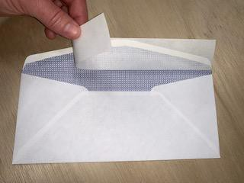
SECURITY & READY TO SEAL
#10 REGULAR $105.29 / 1000

#10 WINDOW $114.79 / 1000
DIGITAL #10 WINDOW $131.00 /1000

02/18/26

BOOKLET AND CATALOG

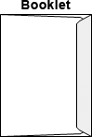
BOOKLET 24# WHITE/WOVE
6 X 9 $52.12 / 1000
6 X 9 WINDOW $64.25 / 1000
6 X 9-1/2 $57.84 / 1000
9 X 12 $105.82 / 1000

BOOKLET 28# WHITE/WOVE
6 X 9 | $66.07 / 1000
6 X 9.5 | $67.42 / 1000
7.5 X 10.5 | $121.84 / 1000
9 X 12 | $108.68 / 1000
9-1/2 X 12-5/8 | $127.56 / 1000
10 X 13 | $133.06 / 1000
10 X 15 | $178.75 / 1000

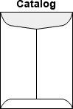
CATALOG 24# WHITE/WOVE
5-1/2 X 7-1/2 | $87.52 / 1000
6 X 9 | $85.66 / 1000
6-1/2 X 9-1/2 | $96.02 / 1000
7 X 10 | $117.55 / 1000
7-1/2 X 10.5 | $128.06/ 1000
9 X 12 | $110.25 / 1000
9 X 12 PEAL | $192.31 /1000

CATALOG 28# WHITE/WOVE
6 X 9 | $96.60 / 1000
7 X 10 | $122.12 / 1000
7-1/2 X 10-1/2 | $131.70 / 1000
9 X 12 | $118.40 / 1000
9 X 12 WINDOW | $149.00 / 1000
9 X 12 PEAL & SEAL $212.31 /
9-1/2 X 12-1/2 $135.75 / 1000
10 X 13 | $136.71 / 1000
6X9 BUFF KRAFT | $118.00 / 1000

LABELS-STICKERS
LABEL STOCK PRESSURE SENSITIVE PERMANET FULL SHEET SIZE
SLIT EVERY 1-1/4 INCH
(PRICE PER PACK OF 100 SHEETS)

 | 8.5 X 11 | 12 X 18
UNCOATED | $31.28 | $49.27
MATTE | $32.89 | $54.52
GLOSS | $35.97 | $61.29
CLEAR | $69.90 | $
VINYL | $ | $123.65

DIE CUT LABELS UNCOATED ON 8.5X11 PERMANENT (PRICE PER PACK OF 100 SHEETS)
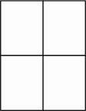
4 UP - 4 1/4 X 5-1/2--$26.50 UNCOATED

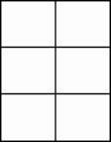
6 UP - 4 X 3-1/2 $26.50 UNCOATED

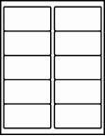
10 UP - 4 X 2 $26.50 UNCOATED

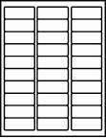
30 UP - 2-5/8 X 1 $26.50 UNCOATED

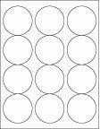
CIRCLES - 2-1/2 $26.50 UNCOATED


CIRCLES - 2” ----------$85.00 GLOSS -GLOSS

11/27/23


03/6/24


GEMINI 96 BRIGHT 20#----------------------------------------------------------------
8.5X11
$56.35/CASE - $11.27/M

11X17
$56.70/CASE - $22.68/M

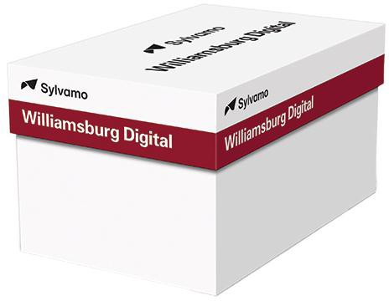
WILLIAMSBURG DIGITAL 94 BRIGHT WHITE 60# AND 70#
(PRICE PER 1000)

 | 8.5X11 | 11X17
60# | $17.77 | $38.00
70# | $ | $44.00

C2S | 12X18 | 13X19
10 POINT | 156.06 | 178.67
12 POINT | 177.42 | 201.81
14 POINT | 199.60 | 228.43
16 POINT | 217.34 | 246.20
18 POINT | 268.35


11/7/23

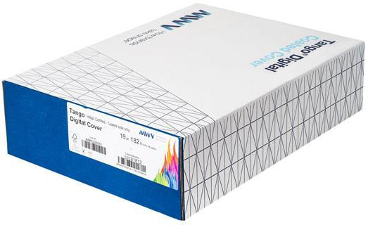
TANGO PRICE PER 1,000 SHEETS
C1S | 12X18 | 13X19
10 POINT | 123.04
12 POINT | 139.85 | 159.81
14 POINT | 157.83 | 179.79
16 POINT | 177.80 | 203.77

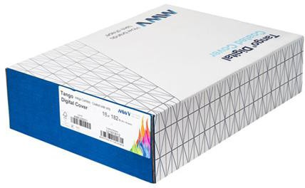

09/30/24

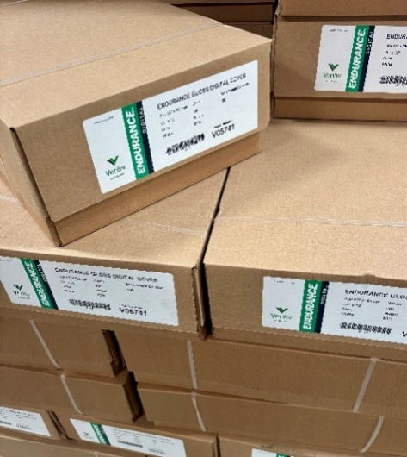
ENDURANCE GLOSS & SILK

 | 11X17 | 12X18 | 13X19
80 TEXT | 50.46  44.00 | 58.59  51.00 | 68.36  60.00
100 TEXT | 63.48  56.00 | 73.25  64.00 | 84.63  74.00
80 COVER | 96.03  85.00 | 109.27  97.00 | 125.82  111.00
100 COVER | 119.20  105.00 | 137.41  122.00 | 158.00  139.00

2/18/26

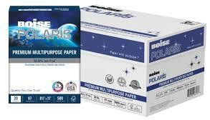
POLARIS DIGITAL BRIGHT WHITE -value brand
(PRICE PER 1000)
 | 8.5X11 | 11X17
24# | 21.00 | $45.11
28# | $24.25 | $51.39


HAMMERMILL LASER
(PRICE PER 1000)
 | 8.5X11 | 8.5X14 | 11X17 | 12X18
24# | $24.30 | $33.10 | $52.04 | $
28# | $28.36 | $ | $60.72 | $
32# | $32.41 | $44.13 | $69.22 | $80.15

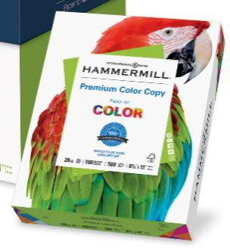
HAMMERMILL COLOR COPY TEXT
(PRICE PER 1000)
 | 8.5X11 | 8.5X14 | 11X17 | 12X18 | 13X19
28# | $31.81 | $42.97 | $67.76 | $78.26 | $98.00
32# | $36.36 | $ | $77.43 | $98.00

HAMMERMILL COLOR COPY COVER
(PRICE PER 1000)
 | 8.5X11 | 11X17 | 12X18
60# | $47.52 | $101.25 | $132.81
80# | $63.39 | $134.99 | $179.00
100# | $79.35 | $168.98 | $194.94

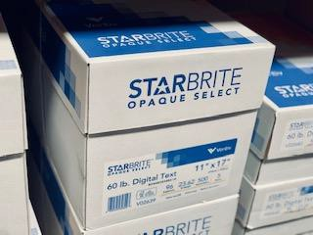

877-312-7827

STARBRITE OPAQUE DIGITAL

PRICE PER 1,000 SHEETS

TEXT | 8.5X11 | 11X17 | 12X18 | 13X19 | 17.5X22.5 | 19X25 | 23X35 | 25X38 | 28X40
50 TEXT | 16.59 | 32.50 | 37.36 |  | 65.00 | 78.87 | 134.10 | 157.76 | 186.15
60 TEXT | 19.60 | 38.39 | 43.19 | 49.58 | 77.58 | 93.11 | 158.29 | 186.21 | 218.80
70 TEXT | 22.87 | 44.79 | 51.18 | 57.58 |  | 108.63 | 184.67 | 217.26 | 256.05
80 TEXT |  |  | 57.18 | 67.17 |  |  | 211.04 | 248.29
100 TEXT |  |  |  |  |  | 155.18 |  | 310.36 | 366.22

COVER | 8.5X11 | 11X17 | 12X18 | 13X19 | 23X35 | 26X40
65 COVER | 38.34 | 76.75 | 88.19 | 101.26 | 297.57 | 384.93
80 COVER |  | 94.72 | 107.78 | 124.12 | 367.25 | 473.85
100 COVER |  |  | 135.62 | 155.22 | 459.04 | 592.28

10/17/23

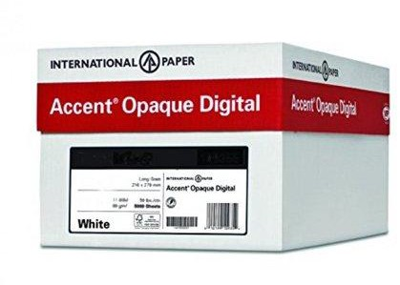
877-312-7827

Accent Opaque White
PRICE PER 1,000 SHEETS

8.5X11 11 X17 12X18
TEXT
60 TEXT | 42.76 | 49.80
70 TEXT | 49.90 | 57.60
80 TEXT | 65.81
100 TEXT | 82.29

8.5X11 11 X17 12X18 13X19
COVER
65 COVER
80 COVER | 49.94 | 106.25 | 123.00
100 COVER | 62.51 | 132.85 | 154.72
120 COVER |  | 244.89 | 280.07
 | - | - | - | -

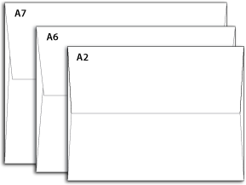
ACCENT OPAQUE 70 TEXT BRIGHT WHITE ANNOUNCEMENTS
A-2 | $ / 1000
A-6 | $ / 1000
A-7 | $ / 1000

04/21/23



GLOBE LINEN (BRIGHT WHITE) -value brand 24# WRITTING
8.5 X 11 $57.00 / 1000
12 X 18 $115.00 / 1000

GLOBE LINEN (BRIGHT WHITE)
84# COVER
8.5 X 11 $122.00 / 1000

100# COVER
8.5 X 11 $205.00 / 1000

GLOBE LINEN (BRIGHT WHITE)
ENVELOPE 24#
#10 $115.00 / 1000

A-2 $CALL/ 1000
A-7 $CALL/ 1000


PHONE 877-312-7827
12/23/21

CLASSIC CREST
AVON BRILLIANT WHITE, NATURAL WHITE, SOLAR WHITE
24# WRITTING
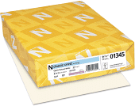
8.5 X 11 $ / 1000

80# COVER
8.5 X 11 $ / 1000

110# COVER
8.5 X 11 $ / 1000

ENVELOPE 24#
#10 $ / 1000

CLASSIC LINEN
AVON BRILLIANT WHITE, NATURAL WHITE, SOLAR WHITE
24# WRITTING
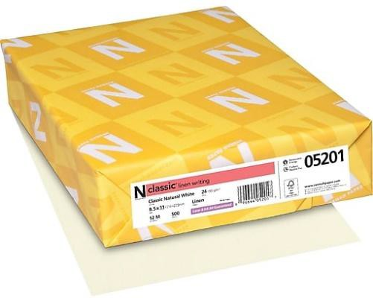
8.5 X 11 $ / 1000

80# COVER
8.5 X 11 $ / 1000

ENVELOPE 24#
#10 $ / 1000

PHONE 877-312-7827

DOMTAR EARTHCHOICE COLOR 20# PASTEL -value brand
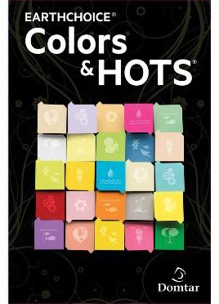
BLUE, CANARY, GOLD, GREEN, IVORY, PINK
20# BOND
8.5 X 11 $ / 1000
11 X 17 $ / 1000

HAMMERMIL MP COLOR 20#
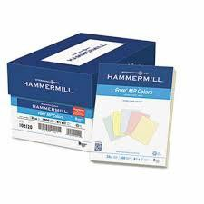
BLUE, BUFF, CANARY, CHERRY, CREAM, GOLD, GRAY, GREEN, IVORY, LILAC, ORCHID, PINK, SALMON, TAN, TURQUOIE
20# BOND
8.5 X 11 $19.35 / 1000
8.5 X 14 $
11 X 17 $ 40.27/ 1000

SPRINGHILL COLORS 60# TEXT
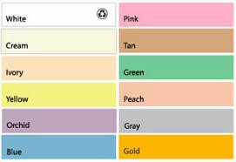
BLUE, BUFF, CANARY, CHERRY, CREAM, GOLD, GRAY, GREEN, IVORY, ORCHID, PINK, SALMON, TAN
60# TEXT
8.5 X 11 $
8.5 X 14 $
11 X 17 $

PHONE 877-312-7827

SPRINGHILL INDEX
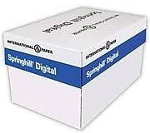
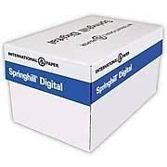
90# INDEX WHITE
8.5 X 11 $
8.5 X 14 $
11 X 17 $

110# INDEX WHITE
8.5 X 11 $
8.5 X 14 $
11 X 17 $103.10/ 1000

SPRINGHILL INDEX COLORS
BLUE, BUFF, CANARY, CHERRY, CREAM, GOLD, GRAY, GREEN, IVORY, ORCHID, PINK, SALMON, TAN
90# INDEX
8.5 X 11 $

110# INDEX
8.5 X 11 $
11 X 17 $

PHONE 877-312-7827

SPRINGHILL VELLUM BRISTOL
WHITE
67#
8.5 X 11 $
8.5 X 14 $
11 X 17 $$80.57

COLORS
BLUE, BUFF, CANARY, CHERRY, CREAM, GOLD, GRAY, GREEN, IVORY, ORCHID, PINK, SALMON, TAN
67#
8.5 X 11 $
11 X 17 $

12/23/21

PHONE 877-312-7827

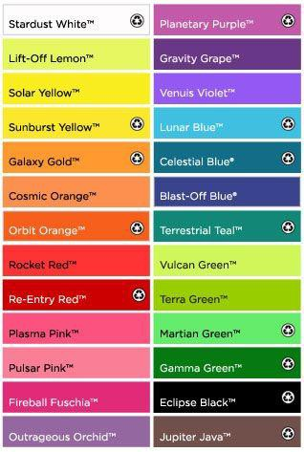
ASTROBRIGHTS
60# TEXT
8.5 X 11 $42.98/ 1000
11 X 17 $

65 COVER
8.5 X 11 $84.00/ 1000

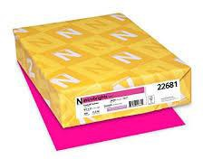

10/17/23
BOXES

FOLDING BUSINESS CARD BOX
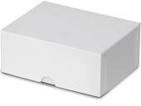
White Claycoated (Folding)
$.73 4-3/4 LENGTH
$.77 7 LENGTH
$.79 10LENGTH
$.82 12 LENGTH

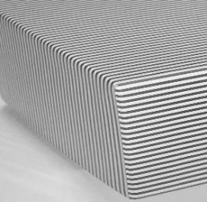
HARD BOX SILVER STRIPE
$ 4-1/4 LENTH
$ 5-3/4 LENGTH
$ 7-1/4 LENGTH
$ 12 LENGTH

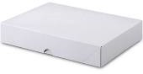
LETTERHEAD BOXES
FOLDING BUSINESS CARD BOX
White Claycoated (Folding)
$.73 8 1/2 X 11 X 2
$1.06 8 1/2 X 11 X 4

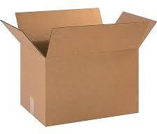
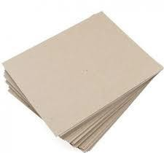
CORRUGATED BOXES (BROWN 200# TEST)
$.62 | 11 1/4 x 8 3/4 x 4-TALL
$.81 | 11 1/4 x 8 3/4 x 6-TALL
$.78 | 11 1/4 x 8 3/4 x 8-TALL
$.80 | 11 1/4 x 8 3/4 x 10-TALL
$.88 | 11 1/4 x 8 3/4 x 12-TALL
$1.32 17 1/4 x 11 1/8 x 11 ¼-TALL
$1.43 18 x 12 x 12-TALL

CHIP BOARD 22 POINT
$30.88/BUNDLE 8.5X11
$23.20/BUNDLE 11X17
$31.54/BUNDLE 12x18

10/17/23

BINDERY

CLEAR COVERS
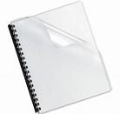
8.5 X 11 | 5 MIL | $12.95/100 PACK
8.5 X 11 | 7 MIL | $16.80/100 PACK
11 X 17 | 7 MIL | $36.40/100 PACK

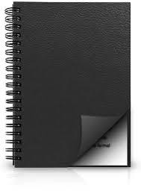
COMPOSITION COVERS
8.5 X 11 BLACK $36.89/100PACK
11 X 17 BLACK $94.75/100PACK


BINDING COIL
BLACK 12” 100/BOX
6MM | $8.04
8MM | $9.87
9MM | $11.24
10MM $13.67
12MM $16.59
14MM $20.15
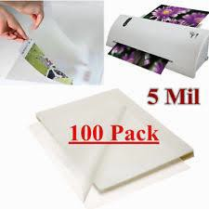
18MM $29.55

LAMINATING POUCH

5 MIL 100/BOX
9 X 11.5 $32.20
9 X 14.5 $40.20
11.5 X 17.5 $62.00
12 X 18 $66.00

10/17/23

SYNTHETIC PAPER -DIGITAL 

(WATERPROOF, TEAR PROOF)
10 MIL 12X18
$104.00 PER 100 SHEETS



10 MIL 12X18
$1,740.00 PER 1000 SHEETS


DIGITAL

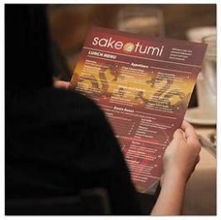
10 MIL 12X18
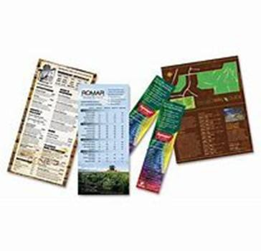
$87.40/ 50 SHEETS

Product Information Alternative to lamination Waterproof, tear-proof, fade resistant
No grain direction Print Compatibility Dry Toner/Laser


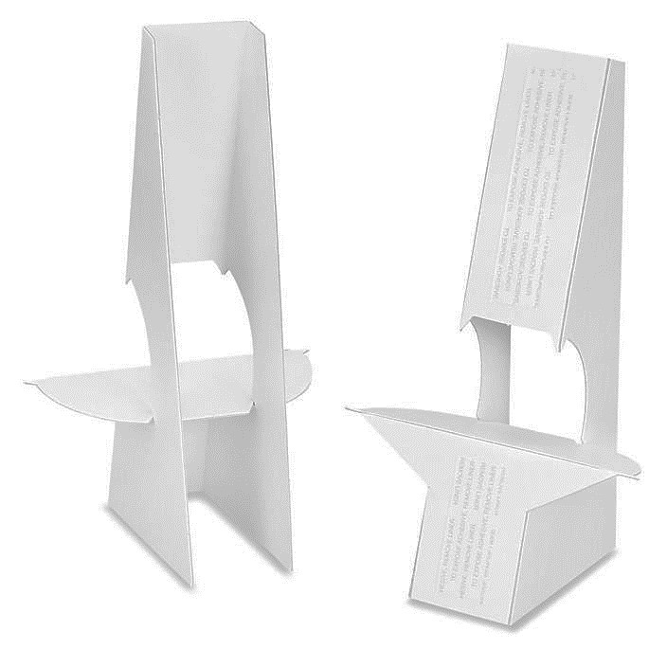
EASELS
8” DOUBLE WING WHITE 40PT
$ -50/PACK

FOAMBOARDS
SELF-ADHESIVE HIGH TACK FOAMBOARD 3/16 WHITE SELF ADHESIVE
$ 203.75 PER- 24X36 25/CARTON
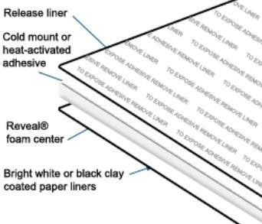

DOOR HANGER JUMBO
2-UP / 500 DOOR HANGERS-PACK / 67 BRISTOL
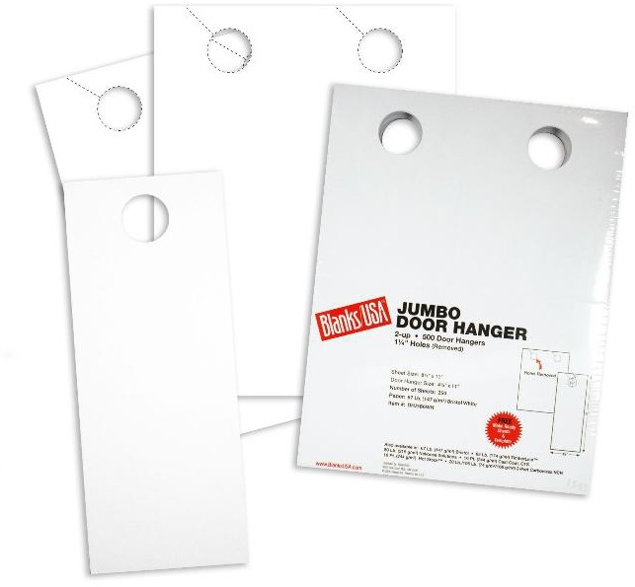
WHITE
$32.00 PER PACK

BLUE, CANARY, GREEN, IVORY
$36.00 PER PACK

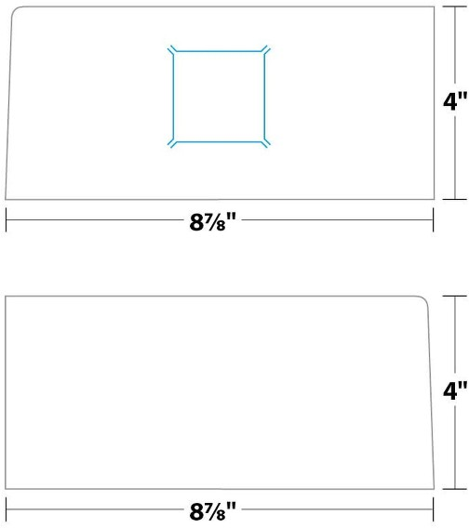
FOLDER POCKET SETS
10-PT CAST COAT C1S
(50 RIGHT POCKET WITH SLIT / 50 LEFT POCKET WITHOUT SLIT)
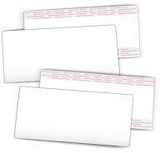
$59.90 PER PACK

10/17/23



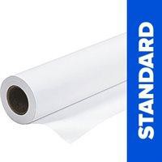
20# ROLLS ENGINEERING BOND
3 INCH CORE, UNTAPTED, FOR INKJET PRINTERS

30 INCHES X 500 FEET
$/ ROLL

36 INCHES X 500 FEET
$/ ROLL


PHONE 877-312-7827
FAX 866-798-1501
EMAIL STARPAPERSTORE@GMAIL.COM

COMPANY NAME

ADDRESS

PHONE FAX

PO#

QUANTITY SIZE WEIGHT DESCRIPTION ITEM CODE

